Auto Learn Nexus: A Task-Ontology Driven Framework for Fully Autonomous Machine Learning Model Generation

DEVELOPED BY:

SANNAPANENI JHASMITHA ROJA

Computer Science and Engineering

Malla Reddy Institute of Technology and Science
Affiliated to Jawaharlal Nehru Technological University Hyderabad (JNTUH)
2022-2026

PROJECT TYPE: Artificial Intelligence & Machine Learning
INDEX

Chapter Page No
ABSTRACT vi
LIST OF FIGURES vii
- INTRODUCTION 01
1.1 EXISTING SYSTEM 01
1.2 PROPOSED SYSTEM 02
1.3 INTRODUCTION 03
- LITERATURE SURVEY 06
- SYSTEM DESIGN 09
  - SYSTEM ARCHITECTURE 09
  - MODULES 10
  - SYSTEM REQUIREMENTS 12
  - UML DIAGRAMS 15
- INPUT AND OUTPUT DEISGN 17
  - INPUT DESIGN 17
  - OUTPUT DESIGN 18
- SOFTWARE ENVIRONMENT 19
  - PYTHON 19
  - DJANGO 28
- SYSTEM STUDY 37
  - ECONOMIC FEASIBILITY 37
  - TECHNICAL FEASIBILITY 38
  - SOCIAL FEASIBILITY 38
- SYSTEM TESTING 39
iv

  - TYPES OF TESTS 39
  - TEST CASES 41
- RESULTS 42
- CONCLUSION 49
- BIBLIOGRAPHY 50

v

ABSTRACT

Recently, many researchers are intensely engaged in investigation on the artificial intelligence technology that recognizes, learns, inferences, and acts on external information in a wide range of fields by combining technologies of computing, big data and machine learning algorithms. The artificial intelligence technology is currently used in almost all industries, and many machine learning experts are working on integrating and standardizing various machine learning tools so that non-experts can easily apply them to their domain. The researchers are also studying an autonomous machine learning as well as ontology construction for standardizing the machine learning concepts. In this paper, we classify typical problem solving steps for autonomous machine learning as tasks, and present a problem solving process. I propose the modeling method of an autonomous machine learning using a process of the task execution on machine learning such as workflow. The proposed task ontology-based machine learning model de fines a task-based process grouping scheme of UML activities. And it will automatically generate and extend the machine learning models by transformation rules based on common elements and structures (relationships and processes between elements).

vi

LIST OF FIGURES

FIGURE NO. FIGURE NAME PAGE NO

Figure.3.1 SYSTEM ARCHITECTURE 10
Figure3.2 DATA FLOW 11
Figure.3.3 USE CASE DIAGRAM 13
Figure.3.4 CLASS DIAGRAM 14
Figure.3.5 SEQUENCE DIAGRAM 15
Figure.3.6 ACTIVITY DIAGRAM 16
Figure.5.1 DJANGO 28
Figure.5.2 DJANGO ADMINISTRATIVE 29
Figure.8.1 RESULT MAIN PAGE 42
Figure.8.2 LOGIN PAGE 42
Figure.8.3 USER SIGN UP PAGE 43
Figure.8.4 USER WELCOME PAGE 43
Figure.8.5 UPLOAD FILES PAGE 44
Figure.8.6 UPLOADED FILES PAGE 44
Figure.8.7 DATABASE ENTERING PAGE 45
Figure.8.8 DATABASE PAGE 45
Figure.8.9 OBJECT IDENTIFICATION FILE UPLOAD PAGE 46
Figure.8.10 RESULT PAGE 46
Figure.8.11 ADMIN LOGIN PAGE 47
Figure.8.12 ADMIN WELCOME PAGE 47
Figure.8.13 TOTAL REGISTERED USERS PAGE 48
Figure.8.14 TOTAL FILES UPLOADED PAGE 48

vii
CHAPTER 1: SYSTEM ANALYSIS

1.1 EXISTING SYSTEM

The domain ontology can be defined as an 'explicit protocol for conceptualization’ of the problem. A task ontology is defined as 'extracting and organizing the concepts and relations existing in the problem solving process domain-independent'. In particular, a task ontology is a specification of the concept structure for the task execution process. Thus, the core concept is the subject of processing and the procedure of processing for a problem solving. In general, a person becomes a subject in a task ontology. However, in this paper, agents (programs) become subjects to perform the tasks.

1.1.1 DISADVANTAGES OF EXISTING SYSTEM

- An autonomous machine learning is still in its infancy, and some techniques provide the ability to reduce the unnecessary tasks that are progressively refined to prepare the model and improve its accuracy.
- ML schema is a top-level ontology that provides classes, properties, and constraints for machine learning algorithms, datasets and experimentation suggested by the W3C(ML Schema community group).

1

1.2 PROPOSED SYSTEM
In the proposed system, we describe a typical problem solving process for the machine learning as tasks, present their procedure, and propose the modeling method of an autonomous machine learning for using task execution processes. The modeling method of autonomous machine learning based on the task ontology define a structure based grouping method of the UML(Unified Modeling Language) activities and implement a function to automatically generate models based on common elements and structures. The purpose of the proposed autonomous machine learning model is to model autonomous machine learning by reusing existing resources and producing new knowledge through relearning it.

1.2.1 ADVANTAGES OF PROPOSED SYSTEM:
- ML schema is a top-level ontology that provides classes, properties, and constraints for machine learning algorithms, datasets and experimentation suggested by the W3C(ML Schema community group).
- It can be easily extended and refined, and can be mapped to other domain ontologies developed in the field of machine learning and data mining.

2

1.3 INTRODUCTION
Artificial intelligence technology has become one of the most essential tools in research and business context recently. Most of the machine learning frameworks are open-source, so the entry of barriers into machine learning are lowered. The typical machine learning frameworks include Tensorflow,Keras[, Caffe, Scikit-learn, and Theano implemented in programming languages such as Python, Java, and R. In this respect, many machine learning experts are working on integrating and standardizing various tools so that machine learning nonexperts can easily apply them to their domains. On the other hand, an autonomous machine learning is still in its infancy, and some techniques provide the ability to reduce the unnecessary tasks that are progressively refined to prepare the model and improve its accuracy. The tools of autonomous machine learning provide an optimal algorithm for machine learning tasks and functions to determine the hyper-parameter setting through self-analysis. The
Task ontologies
Ontology is defined in various fields depending on the field of applications. In the field of artificial intelligence, it is an explicit and formal specification of how objects and concepts described in the field of interest. In the Semantic Web, an ontology plays a very important role in processing, sharing, and reusing the knowledge for exchanging information between different databases. An ontology is also defined as an explicit description of concepts, attributes, constraints, and relationships between them on the domains.On the other hand, domain ontology can be defined as an 'explicit protocol for conceptualization’ of the problem. A task ontology is defined as 'extracting and organizing the concepts and relations existing in the problem solving process domain-independent'. In particular, a task ontology is a specification of the concept structure for the task execution process.
3
Machine learning ontologies
ML schema is a top-level ontology that provides classes, properties, and constraints for machine learning algorithms, datasets and experimentation suggested by the W3C(ML Schema community group). It can be easily extended and refined, and can be mapped to other domain ontologies developed in the field of machine learning and data mining. MEX vocabulary has been designed to solve the share of provenance information in a lightweight form.

Autonomous machine learning modeling
Autonomous machine learning modeling is the work for standardization and abstraction to the core of the components base on the meta information ofmachine learning. The model consists of the task and process and saves as the method library(API). It defines into small units for modular and systematization of its components. The defined components redefine as a UML-based metamodel for the consistency, traceability, reusability, and implementation-ready between tasks and the results. So the core class of the UML-based meta-model consist of tasks and processes.

4
The Knowledge of the autonomous machine learning also describes a small task unit based on the MEXvocabulary. depicts a part of the knowledge of the object detection using the “YOLO” of the deep learning algorithm. The machine learning pipeline for object detection consists of data import, decision of attribute selection or schema, selection of learning model, construction of learning model, hyper-parameter setting, model training, measurement of model performance, and so on. In this way, the knowledge representation of the project unit is written as ‘.json’ files using the mapping rules based on the machine learning schema and the vocabulary, and convert it into a UML-based meta-model. This model makes that objectives, optimizers, metrics, and layers in the Keras API are meta-model for deep learning.

5
CHAPTER 2: LITERATURE SURVEY

2.1) TensorFlow:
A system for large-scale machine learning
AUTHORS: Mart´ın Abadi, Paul Barham, Jianmin Chen, Zhifeng Chen, Andy Davis, Jeffrey Dean, Matthieu Devin, Sanjay Ghemawat, Geoffrey Irving, Michael Isard, Manjunath Kudlur, Josh Levenberg, Rajat Monga, Sherry Moore, Derek G. Murray, Benoit Steiner, Paul Tucker, Vijay Vasudevan, Pete Warden, Martin Wicke, Yuan Yu, and Xiaoqiang Zheng

TensorFlow is a machine learning system that operates at large scale and in heterogeneous environments. TensorFlow uses dataflow graphs to represent computation, shared state, and the operations that mutate that state. It maps the nodes of a dataflow graph across many machines in a cluster, and within a machine across multiple computational devices, including multicore CPUs, generalpurpose GPUs, and custom-designed ASICs known as Tensor Processing Units (TPUs).

2.2) Caffe:
Convolutional Architecture for Fast Feature Embedding
AUTHORS: Yangqing Jia∗ , Evan Shelhamer∗ , Jeff Donahue, Sergey Karayev, Jonathan Long, Ross Girshick, Sergio Guadarrama, Trevor Darrell SUBMITTED to ACM MULTIMEDIA 2014 OPEN SOURCE SOFTWARE COMPETITION UC Berkeley EECS, Berkeley, CA 94702.
Caffe provides multimedia scientists and practitioners with a clean and modifiable framework for state-of-the-art deep learning algorithms and a collection of reference models. The framework is a BSD-licensed C++ library
6

2.3. Exposé: An ontology for data mining experiments

AUTHORS: V. Joaquin, S. LarisaResearch in machine learning and data mining can be speeded up tremendously by moving empirical research results out of people's heads and labs, onto the network and into tools that help us structure and filter the information. This paper presents Exposé, an ontology to describe machine learning experiments in a standardized fashion and support a collaborative approach to the analysis of learning algorithms. Using a common vocabulary, data mining experiments and details of the used algorithms and datasets can be shared between individual re-searchers, software agents, and the community at large. It enables open repositories that collect and organize experiments by many researchers. As can been learned from recent developments in other sciences, such a free exchange and reuse of experiments requires a clear representation. We therefore focus on the design of an ontology to express and share experiment meta-data with the world.

2.4. Task ontology:
Ontology for building conceptual problem solving models
AUTHORS: I. Mitsuru, S. Kazuhisa, K. Osamu, M. Riichiro
We have investigated the property of problem solving knowledge and tried to design its ontology, that is, Task ontology. The main purpose of this paper is to illustrate a Conceptual LEvel Programming Environment (named CLEPE) as an implemented system based on Task ontology. CLEPE provides three major advantages as follows

7
The systems with task ontology can simulate the problem solving process at an abstract level in terms of conceptual level primitives (conceptual level operationality). (C) It provides ontology author with an environment for building task ontology so that he/she can build a consistent and useful ontology. In this paper, firstly we briefly introduce the concept of task ontology. Secondly, CLEPE and its design principle is described. In CLEPE, one can represent his/her own problem solving knowledge and realize the conceptual-level execution.

2.5. Models for Representing Task Ontologies
AUTHORS: A. F. Martins, R. A. F. De
Knowledge is of general utility and should be captured thinking in reuse. A key idea underlining knowledge capturing for reuse is to consider that there are two major kinds of knowledge: domain and task knowledge. Ontologies can be used for representing both kinds of knowledge. However, while domain ontologies are broadly used and there are many proposals of models for representing them, the same does not occur for task ontologies. In this paper we propose the use of UML activity diagrams for capturing task control-flow, and UML class diagrams for capturing the knowledge roles involved in its activities. We also discuss the interrelationship between these two models and how they can be combined with domain ontologies in order to describe the knowledge involved in a class of applications.

8
CHAPTER 3: SYSTEM DESIGN

3.1 SYSTEM REQUIREMENTS
3.1.1.HARDWARE REQUIREMENTS:

- System : Pentium Dual Core.
- Hard Disk : 500 GB.
- Monitor : 15’’ LED
- Input Devices : Keyboard, Mouse
- Ram : 1GB.

3.1.2.SOFTWARE REQUIREMENTS:

- Operating system : Windows 7.
- Coding Language : Python
- Tool : PyCharm, Visual Studio Code
- Database : MYSQL
- Framework : Django

9

3.2 SYSTEM ARCHITECTURE:
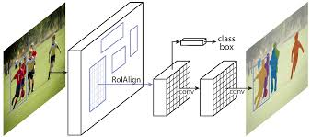
Figure.1 System Architecture

DATA FLOW DIAGRAM:

- The DFD is also called as bubble chart. It is a simple graphical formalism that can be used to represent a system in terms of input data to the system, various processing carried out on this data, and the output data is generated by this system.
- The data flow diagram (DFD) is one of the most important modeling tools. It is used to model the system components. These components are the system process, the data used by the process, an external entity that interacts with the system and the information flows in the system.
- DFD shows how the information moves through the system and how it is modified by a series of transformations. It is a graphical technique that depicts information flow and the transformations that are applied as data moves from input to output.
DFD is also known as bubble chart. A DFD may be used to represent a system at any level of abstraction. DFD may be partitioned into levels that represent increasing information flow and functional detail.
10
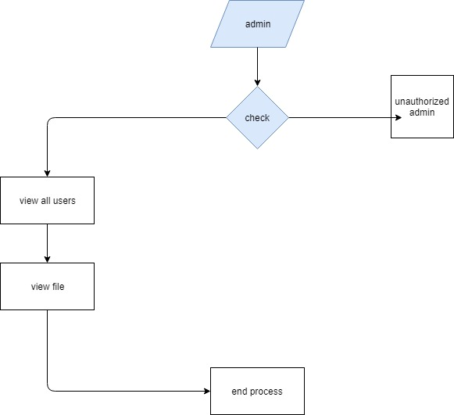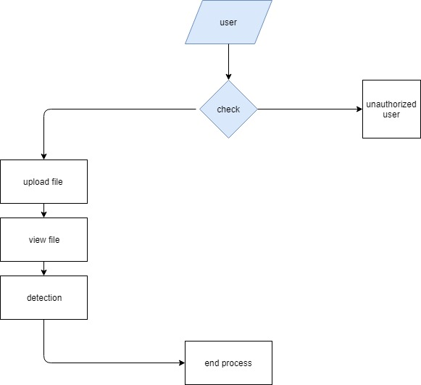

Figure.2 Data flow
11
3.3 UML DIAGRAMS

UML stands for Unified Modeling Language. UML is a standardized general-purpose modeling language in the field of object-oriented software engineering. The standard is managed, and was created by, the Object Management Group.
The goal is for UML to become a common language for creating models of object oriented computer software. In its current form UML is comprised of two major components: a Meta-model and a notation. In the future, some form of method or process may also be added to; or associated with, UML.
The Unified Modeling Language is a standard language for specifying, Visualization, Constructing and documenting the artifacts of software system, as well as for business modeling and other non-software systems.
The UML represents a collection of best engineering practices that have proven successful in the modeling of large and complex systems.
The UML is a very important part of developing objects oriented software and the software development process. The UML uses mostly graphical notations to express the design of software projects.

GOALS:
The Primary goals in the design of the UML are as follows:
- Provide users a ready-to-use, expressive visual modeling Language so that they can develop and exchange meaningful models.
- Provide extendibility and specialization mechanisms to extend the core concepts.
- Be independent of particular programming languages and development process.
- Provide a formal basis for understanding the modeling language.
12
- Encourage the growth of OO tools market.
- Support higher level development concepts such as collaborations, frameworks, patterns and components.
- Integrate best practices.

3.3.1 USE CASE DIAGRAM

A use case diagram in the Unified Modeling Language (UML) is a type of behavioral diagram defined by and created from a Use-case analysis. Its purpose is to present a graphical overview of the functionality provided by a system in terms of actors, their goals (represented as use cases), and any dependencies between those use cases. The main purpose of a use case diagram is to show what system functions are performed for which actor. Roles of the actors in the system can be depicted.

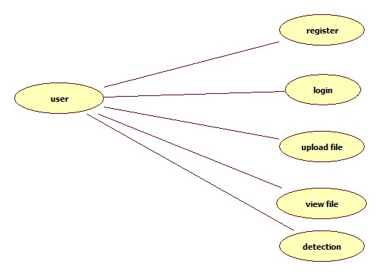

13
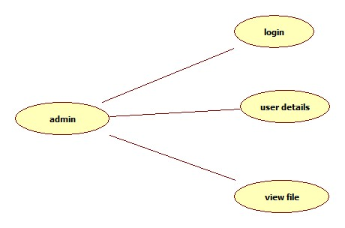
Figure.3 use case diagram

3.3.2 CLASS DIAGRAM

In software engineering, a class diagram in the Unified Modeling Language (UML) is a type of static structure diagram that describes the structure of a system by showing the system's classes, their attributes, operations (or methods), and the relationships among the classes. It explains which class contains information.
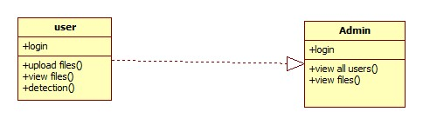
Figure.4 class diagram

14
3.3.3 SEQUENCE DIAGRAM

A sequence diagram in Unified Modeling Language (UML) is a kind of interaction diagram that shows how processes operate with one another and in what order. It is a construct of a Message Sequence Chart. Sequence diagrams are sometimes called event diagrams, event scenarios, and timing diagrams.

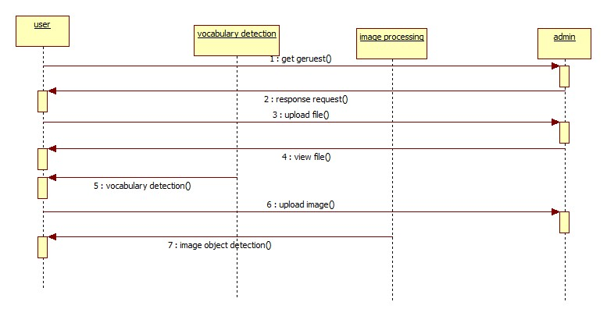

Figure.5 sequence diagram

3.4 ACTIVITY DIAGRAM

Activity diagrams are graphical representations of workflows of stepwise activities and actions with support for choice, iteration and concurrency. In the Unified Modeling Language, activity diagrams can be used to describe the business and operational step-by-step workflows of components in a system. An activity diagram shows the overall flow of control.

15

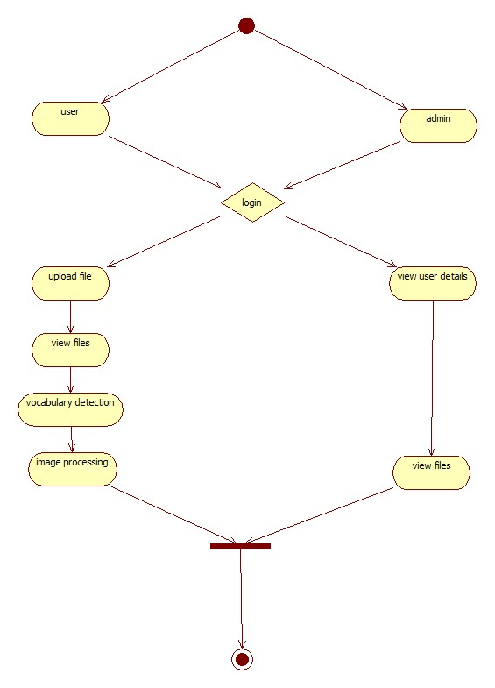

Figure.6 activity diagram

16
CHAPTER 4: INPUT AND OUTPUT DESIGN

4.1 INPUT DESIGN

The input design is the link between the information system and the user. It comprises the developing specification and procedures for data preparation and those steps are necessary to put transaction data in to a usable form for processing can be achieved by inspecting the computer to read data from a written or printed document or it can occur by having people keying the data directly into the system. The design of input focuses on controlling the amount of input required, controlling the errors, avoiding delay, avoiding extra steps and keeping the process simple. The input is designed in such a way so that it provides security and ease of use with retaining the privacy. Input Design considered the following things:
- What data should be given as input?
- How the data should be arranged or coded?
- The dialog to guide the operating personnel in providing input.
- Methods for preparing input validations and steps to follow when error occur.

OBJECTIVES
1.Input Design is the process of converting a user-oriented description of the input into a computer-based system. This design is important to avoid errors in the data input process and show the correct direction to the management for getting correct information from the computerized system.
2. It is achieved by creating user-friendly screens for the data entry to handle large volume of data. The goal of designing input is to make data entry easier and to be free from errors. The data entry screen is designed in such a way that all the data manipulates can be performed. It also provides record viewing facilities.
3.When the data is entered it will check for its validity. Data can be entered with the help of screens. Appropriate messages are provided as when needed so that the user will not be in maize of instant. Thus the objective of input design is to create an input layout that is easy to follow

17

4.2 OUTPUT DESIGN

A quality output is one, which meets the requirements of the end user and presents the information clearly. In any system results of processing are communicated to the users and to other system through outputs. In output design it is determined how the information is to be displaced for immediate need and also the hard copy output. It is the most important and direct source information to the user. Efficient and intelligent output design improves the system’s relationship to help user decision-making.

1. Designing computer output should proceed in an organized, well thought out manner; the right output must be developed while ensuring that each output element is designed so that people will find the system can use easily and effectively. When analysis design computer output, they should Identify the specific output that is needed to meet the requirements.

2.Select methods for presenting information.

3.Create document, report, or other formats that contain information produced by the system.

The output form of an information system should accomplish one or more of the following objectives.

- Convey information about past activities, current status or projections of the
- Future.
- Signal important events, opportunities, problems, or warnings.
- Trigger an action.
- Confirm an action.

18
CHAPTER 5: SOFTWARE ENVIRONMENT

5.1PYTHON

Python is a general-purpose interpreted, interactive, object-oriented, and high-level programming language. An interpreted language, Python has a design philosophy that emphasizes code readability (notably using whitespace indentation to delimit code blocks rather than curly brackets or keywords), and a syntax that allows programmers to express concepts in fewer lines of code than might be used in languages such as C++or Java. It provides constructs that enable clear programming on both small and large scales. Python interpreters are available for many operating systems. CPython, the reference implementation of Python, is open source software and has a community-based development model, as do nearly all of its variant implementations. CPython is managed by the non-profit Python Software Foundation. Python features a dynamic type system and automatic memory management. It supports multiple programming paradigms, including object-oriented, imperative, functional and procedural, and has a large and comprehensive standard library.
Interactive Mode Programming
Invoking the interpreter without passing a script file as a parameter brings up the following prompt −

$ python
Python 2.4.3 (#1, Nov 11 2010, 13:34:43)
[GCC 4.1.2 20080704 (Red Hat 4.1.2-48)] on linux2
Type "help", "copyright", "credits" or "license" for more information.
19
Type the following text at the Python prompt and press the Enter −

>>> print "Hello, Python!"
If you are running new version of Python, then you would need to use print statement with parenthesis as in print ("Hello, Python!");. However in Python version 2.4.3, this produces the following result −

Hello, Python!
Script Mode Programming
Invoking the interpreter with a script parameter begins execution of the script and continues until the script is finished. When the script is finished, the interpreter is no longer active.

Let us write a simple Python program in a script. Python files have extension .py. Type the following source code in a test.py file −

Live Demo
print "Hello, Python!"
We assume that you have Python interpreter set in PATH variable. Now, try to run this program as follows −

$ python test.py
This produces the following result −

Hello, Python!
Let us try another way to execute a Python script. Here is the modified test.py file −

20
#!/usr/bin/python

print "Hello, Python!"
We assume that you have Python interpreter available in /usr/bin directory. Now, try to run this program as follows −

$ chmod +x test.py # This is to make file executable
$./test.py
This produces the following result −

Hello, Python!
Python Identifiers
A Python identifier is a name used to identify a variable, function, class, module or other object. An identifier starts with a letter A to Z or a to z or an underscore (_) followed by zero or more letters, underscores and digits (0 to 9).

Python does not allow punctuation characters such as @, $, and % within identifiers. Python is a case sensitive programming language. Thus, Manpower and manpower are two different identifiers in Python.

Here are naming conventions for Python identifiers −

Class names start with an uppercase letter. All other identifiers start with a lowercase letter.

Starting an identifier with a single leading underscore indicates that the identifier is private Starting an identifier with two leading underscores indicates a strongly private identifier.
21
If the identifier also ends with two trailing underscores, the identifier is a language-defined special name.

Reserved Words
The following list shows the Python keywords. These are reserved words and you cannot use them as constant or variable or any other identifier names. All the Python keywords contain lowercase letters only.

and exec not assert finally or
break for pass
class from print
continue global raise
def if return
del import try
elif in while
else is with
except lambda yield

Lines and Indentation
Python provides no braces to indicate blocks of code for class and function definitions or flow control. Blocks of code are denoted by line indentation, which is rigidly enforced.

The number of spaces in the indentation is variable, but all statements within the block must be indented the same amount. For example −

if True:
print "True"
else:
print "False"
22
However, the following block generates an error −

if True:
print "Answer"
print "True"
else:
print "Answer"
print "False"
Thus, in Python all the continuous lines indented with same number of spaces would form a block. The following example has various statement blocks −

Note − Do not try to understand the logic at this point of time. Just make sure you understood various blocks even if they are without braces.

#!/usr/bin/python

import sys

try:
# open file stream
file = open(file_name, "w")
except IOError:
print "There was an error writing to", file_name
sys.exit()
print "Enter '", file_finish,
print "' When finished"
while file_text != file_finish:
file_text = raw_input("Enter text: ")
23
# close the file
file.close
break
file.write(file_text)
file.write("\n")
file.close()
file_name = raw_input("Enter filename: ")
if len(file_name) == 0:
print "Next time please enter something"
sys.exit()
try:
file = open(file_name, "r")
except IOError:
print "There was an error reading file"
sys.exit()
file_text = file.read()
file.close()
print file_text
Multi-Line Statements
Statements in Python typically end with a new line. Python does, however, allow the use of the line continuation character (\) to denote that the line should continue. For example −

total = item_one + \
item_two + \
item_three
Statements contained within the [], {}, or () brackets do not need to use the line continuation character. For example −
24
days = ['Monday', 'Tuesday', 'Wednesday',
'Thursday', 'Friday']
Quotation in Python
Python accepts single ('), double (") and triple (''' or """) quotes to denote string literals, as long as the same type of quote starts and ends the string.

The triple quotes are used to span the string across multiple lines. For example, all the following are legal −

word = 'word'
sentence = "This is a sentence."
paragraph = """This is a paragraph. It is
made up of multiple lines and sentences."""
Comments in Python
A hash sign (#) that is not inside a string literal begins a comment. All characters after the # and up to the end of the physical line are part of the comment and the Python interpreter ignores them.

Live Demo
#!/usr/bin/python

# First comment
print "Hello, Python!" # second comment
This produces the following result −

Hello, Python!
You can type a comment on the same line after a statement or expression −
name = "Madisetti" # This is again comment
25
You can comment multiple lines as follows −

# This is a comment.
# This is a comment, too.
# This is a comment, too.
# I said that already.
Following triple-quoted string is also ignored by Python interpreter and can be used as a multiline comments:
'''
This is a multiline
comment.
'''
Using Blank Lines
A line containing only whitespace, possibly with a comment, is known as a blank line and Python totally ignores it.

In an interactive interpreter session, you must enter an empty physical line to terminate a multiline statement.

Waiting for the User
The following line of the program displays the prompt, the statement saying “Press the enter key to exit”, and waits for the user to take action −

#!/usr/bin/python
raw_input("\n\nPress the enter key to exit.")

Here, "\n\n" is used to create two new lines before displaying the actual line. Once the user presses the key, the program ends.
26
This is a nice trick to keep a console window open until the user is done with an application.
Multiple Statements on a Single Line
The semicolon ( ; ) allows multiple statements on the single line given that neither statement starts a new code block. Here is a sample snip using the semicolon.
import sys; x = 'foo'; sys.stdout.write(x + '\n')
Multiple Statement Groups as Suites
A group of individual statements, which make a single code block are called suites in Python. Compound or complex statements, such as if, while, def, and class require a header line and a suite.
Header lines begin the statement (with the keyword) and terminate with a colon ( : ) and are followed by one or more lines which make up the suite.

27

5.2 DJANGO

Django is a high-level Python Web framework that encourages rapid development and clean, pragmatic design. Built by experienced developers, it takes care of much of the hassle of Web development, so you can focus on writing your app without needing to reinvent the wheel. It’s free and open source.
Django's primary goal is to ease the creation of complex, database-driven websites. Django emphasizes reusabilityand "pluggability" of components, rapid development, and the principle of don't repeat yourself. Python is used throughout, even for settings files and data models.

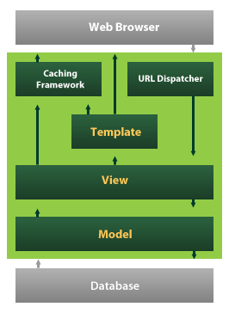
Figure.7 Django
Django also provides an optional administrative create, read, update and delete interface that is generated dynamically through introspection and conFigureured via admin models
28
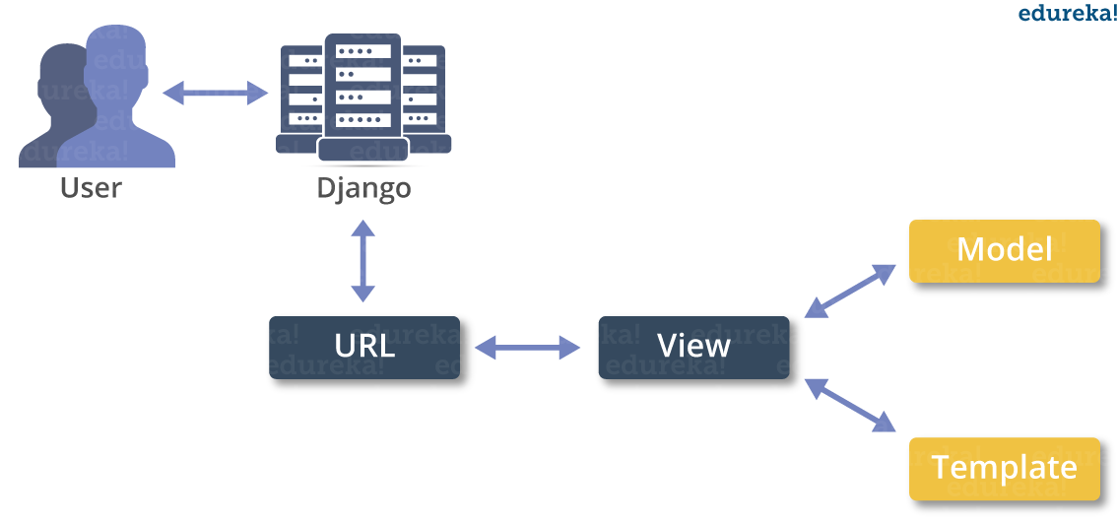
Figure.8 Django Administrative
Create a Project
Whether you are on Windows or Linux, just get a terminal or a cmd prompt and navigate to the place you want your project to be created, then use this code −

$ django-admin startproject myproject
This will create a "myproject" folder with the following structure −
myproject/
manage.py
myproject/
__init__.py
settings.py
urls.py
wsgi.py
The Project Structure
The “myproject” folder is just your project container, it actually contains two elements −
manage.py − This file is kind of your project local django-admin for interacting with your project via command line (start the development server, sync db...).
29
To get a full list of command accessible via manage.py you can use the code −

$ python manage.py help
The “myproject” subfolder − This folder is the actual python package of your project. It contains four files −

__init__.py − Just for python, treat this folder as package.

settings.py − As the name indicates, your project settings.

urls.py − All links of your project and the function to call. A kind of ToC of your project.

wsgi.py − If you need to deploy your project over WSGI.

Setting Up Your Project
Your project is set up in the subfolder myproject/settings.py. Following are some important options you might need to set −

DEBUG = True
This option lets you set if your project is in debug mode or not. Debug mode lets you get more information about your project's error. Never set it to ‘True’ for a live project. However, this has to be set to ‘True’ if you want the Django light server to serve static files. Do it only in the development mode.0
DATABASES = {
'default': {
'ENGINE': 'django.db.backends.sqlite3',
'NAME': 'database.sql',
30
'USER': '',
'PASSWORD': '',
'HOST': '',
'PORT': '',
}
}
Database is set in the ‘Database’ dictionary. The example above is for SQLite engine. As stated earlier, Django also supports −

MySQL (django.db.backends.mysql)
PostGreSQL (django.db.backends.postgresql_psycopg2)
Oracle (django.db.backends.oracle) and NoSQL DB
MongoDB (django_mongodb_engine)
Before setting any new engine, make sure you have the correct db driver installed.

You can also set others options like: TIME_ZONE, LANGUAGE_CODE, TEMPLATE…

Now that your project is created and conFigureured make sure it's working −

$ python manage.py runserver
You will get something like the following on running the above code −

Validating models...
0 errors found
September 03, 2015 - 11:41:50
Django version 1.6.11, using settings 'myproject.settings'
31
Starting development server at http://127.0.0.1:8000/
Quit the server with CONTROL-C.

A project is a sum of many applications. Every application has an objective and can be reused into another project, like the contact form on a website can be an application, and can be reused for others. See it as a module of your project.

Create an Application
We assume you are in your project folder. In our main “myproject” folder, the same folder then manage.py −

$ python manage.py startapp myapp
You just created myapp application and like project, Django create a “myapp” folder with the application structure −

myapp/
__init__.py
admin.py
models.py
tests.py
views.py
__init__.py − Just to make sure python handles this folder as a package.

admin.py − This file helps you make the app modifiable in the admin interface.

models.py − This is where all the application models are stored.

tests.py − This is where your unit tests are.
32
views.py − This is where your application views are.

Get the Project to Know About Your Application
At this stage we have our "myapp" application, now we need to register it with our Django project "myproject". To do so, update INSTALLED_APPS tuple in the settings.py file of your project (add your app name) −

INSTALLED_APPS = (
'django.contrib.admin',
'django.contrib.auth',
'django.contrib.contenttypes',
'django.contrib.sessions',
'django.contrib.messages',
'django.contrib.staticfiles',
'myapp',
)
Creating forms in Django, is really similar to creating a model. Here again, we just need to inherit from Django class and the class attributes will be the form fields. Let's add a forms.py file in myapp folder to contain our app forms. We will create a login form.

myapp/forms.py

#-*- coding: utf-8 -*-
from django import forms

class LoginForm(forms.Form):
user = forms.CharField(max_length = 100)
33
password = forms.CharField(widget = forms.PasswordInput())
As seen above, the field type can take "widget" argument for html rendering; in our case, we want the password to be hidden, not displayed. Many others widget are present in Django: DateInput for dates, CheckboxInput for checkboxes, etc.

Let's create a login view in our myapp/views.py −

#-*- coding: utf-8 -*-
from myapp.forms import LoginForm

def login(request):
username = "not logged in"

if request.method == "POST":
#Get the posted form
MyLoginForm = LoginForm(request.POST)

if MyLoginForm.is_valid():
username = MyLoginForm.cleaned_data['username']
else:
MyLoginForm = Loginform()

return render(request, 'loggedin.html', {"username" : username})
The view will display the result of the login form posted through the loggedin.html. To test it, we will first need the login form template. Let's call it login.html.
<html>
<body>
34
<form name = "form" action = "{% url "myapp.views.login" %}"
method = "POST" >{% csrf_token %}

<div style = "max-width:470px;">
<center>
<input type = "text" style = "margin-left:20%;"
placeholder = "Identifiant" name = "username" />
</center>
</div>

<br>

<div style = "max-width:470px;">
<center>
<input type = "password" style = "margin-left:20%;"
placeholder = "password" name = "password" />
</center>
</div>

<br>

<div style = "max-width:470px;">
<center>
<button style = "border:0px; background-color:#4285F4; margin-top:8%;
height:35px; width:80%;margin-left:19%;" type = "submit"
value = "Login" >
<strong>Login</strong>
35
</button>

</center>
</div>

</form>
</body>
</html>
The template will display a login form and post the result to our login view above. You have probably noticed the tag in the template, which is just to prevent Cross-site Request Forgery (CSRF) attack on your site.
{% csrf_token %}Once we have the login template, we need the loggedin.html template that will be rendered after form treatment.

36

CHAPTER 6: SYSTEM STUDY

6.1.FEASIBILITY STUDY
The feasibility of the project is analyzed in this phase and business proposal is put forth with a very general plan for the project and some cost estimates. During system analysis the feasibility study of the proposed system is to be carried out. This is to ensure that the proposed system is not a burden to the company. For feasibility analysis, some understanding of the major requirements for the system is essential.

Three key considerations involved in the feasibility analysis are,
- ECONOMICAL FEASIBILITY
- TECHNICAL FEASIBILITY
- SOCIAL FEASIBILITY

6.2.ECONOMICAL FEASIBILITY
This study is carried out to check the economic impact that the system will have on the organization. The amount of fund that the company can pour into the research and development of the system is limited. The expenditures must be justified. Thus the developed system as well within the budget and this was achieved because most of the technologies used are freely available. Only the customized products had to be purchased.
37

6.3.TECHNICAL FEASIBILITY
This study is carried out to check the technical feasibility, that is, the technical requirements of the system. Any system developed must not have a high demand on the available technical resources. This will lead to high demands on the available technical resources. This will lead to high demands being placed on the client. The developed system must have a modest requirement, as only minimal or null changes are required for implementing this system.

6.4.SOCIAL FEASIBILITY
The aspect of study is to check the level of acceptance of the system by the user. This includes the process of training the user to use the system efficiently. The user must not feel threatened by the system, instead must accept it as a necessity. The level of acceptance by the users solely depends on the methods that are employed to educate the user about the system and to make him familiar with it. His level of confidence must be raised so that he is also able to make some constructive criticism, which is welcomed, as he is the final user of the system.

38
CHAPTER 7: SYSTEM TESTING
The purpose of testing is to discover errors. Testing is the process of trying to discover every conceivable fault or weakness in a work product. It provides a way to check the functionality of components, sub assemblies, assemblies and/or a finished product It is the process of exercising software with the intent of ensuring that the Software system meets its requirements and user expectations and does not fail in an unacceptable manner. There are various types of test. Each test type addresses a specific testing requirement.

7.1TYPES OF TESTS

7.1.1 Unit testing
Unit testing involves the design of test cases that validate that the internal program logic is functioning properly, and that program inputs produce valid outputs. All decision branches and internal code flow should be validated. It is the testing of individual software units of the application .it is done after the completion of an individual unit before integration. This is a structural testing, that relies on knowledge of its construction and is invasive. Unit tests perform basic tests at component level and test a specific business process, application, and/or system conFigureuration. Unit tests ensure that each unique path of a business process performs accurately to the documented specifications and contains clearly defined inputs and expected results.

7.1.2. Integration testing
Integration tests are designed to test integrated software components to determine if they actually run as one program. Testing is event driven and is more concerned with the basic outcome of screens or fields. Integration tests demonstrate that although the components were individually satisfaction, as shown by successfully unit testing, the combination of components is correct and consistent. Integration testing is specifically aimed at exposing the problems that arise from the combination of components.

39

7.1.3. Functional test

Functional tests provide systematic demonstrations that functions tested are available as specified by the business and technical requirements, system documentation, and user manuals.
Functional testing is centered on the following items:
Valid Input : identified classes of valid input must be accepted.
Invalid Input : identified classes of invalid input must be rejected.
Functions : identified functions must be exercised.
Output : identified classes of application outputs must be exercised.
Systems/Procedures : interfacing systems or procedures must be invoked.
Organization and preparation of functional tests is focused on requirements, key functions, or special test cases. In addition, systematic coverage pertaining to identify Business process flows; data fields, predefined processes, and successive processes must be considered for testing. Before functional testing is complete, additional tests are identified and the effective value of current tests is determined.

System Test
System testing ensures that the entire integrated software system meets requirements. It tests a conFigureuration to ensure known and predictable results. An example of system testing is the conFigureuration oriented system integration test. System testing is based on process descriptions and flows, emphasizing pre-driven process links and integration points.

White Box Testing
White Box Testing is a testing in which in which the software tester has knowledge of the inner workings, structure and language of the software, or at least its purpose. It is purpose. It is used to test areas that cannot be reached from a black box level.

Black Box Testing

Black Box Testing is testing the software without any knowledge of the inner workings, structure or language of the module being tested. Black box tests, as most other kinds of tests, must be written from a definitive source document, such as specification or requirements document, such as specification or requirements document. It is a testing in which the software under test is treated, as a black box .you cannot “see” into it. The test provides inputs and responds to outputs without considering how the software works.

40
Unit Testing
Unit testing is usually conducted as part of a combined code and unit test phase of the software lifecycle, although it is not uncommon for coding and unit testing to be conducted as two distinct phases.
Test strategy and approach
Field testing will be performed manually and functional tests will be written in detail.
Test objectives
- All field entries must work properly.
- Pages must be activated from the identified link.
- The entry screen, messages and responses must not be delayed.

Features to be tested
- Verify that the entries are of the correct format
- No duplicate entries should be allowed
- All links should take the user to the correct page.

Integration Testing
Software integration testing is the incremental integration testing of two or more integrated software components on a single platform to produce failures caused by interface defects.
The task of the integration test is to check that components or software applications, e.g. components in a software system or – one step up – software applications at the company level – interact without error.
Test Results: All the test cases mentioned above passed successfully. No defects encountered.

Acceptance Testing
User Acceptance Testing is a critical phase of any project and requires significant participation by the end user. It also ensures that the system meets the functional requirements.
Test Results: All the test cases mentioned above passed successfully. No defects encountered.
41

CHAPTER 8: RESULTS

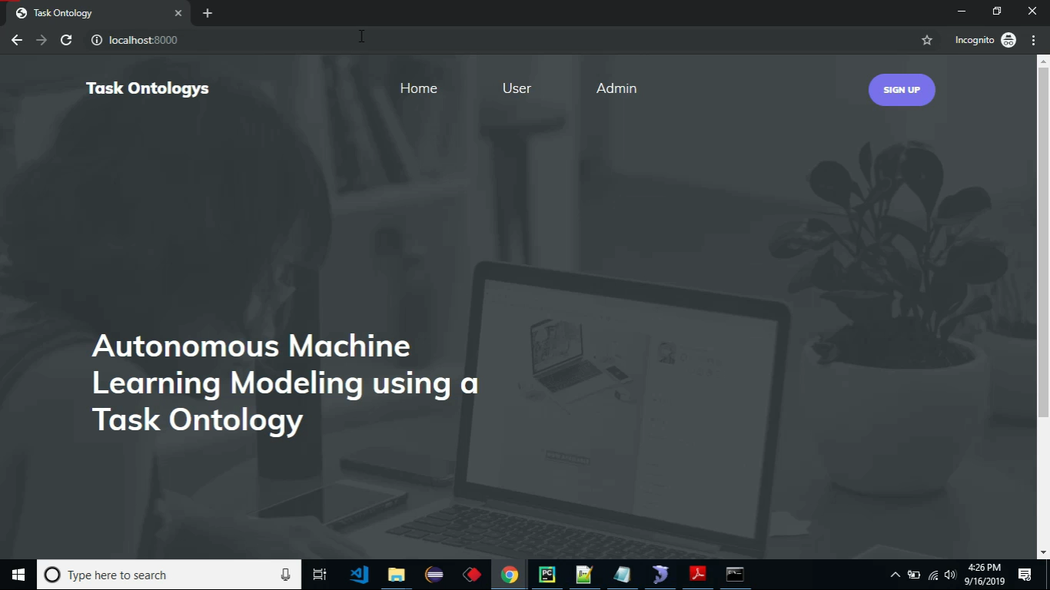
Figure.9 main page
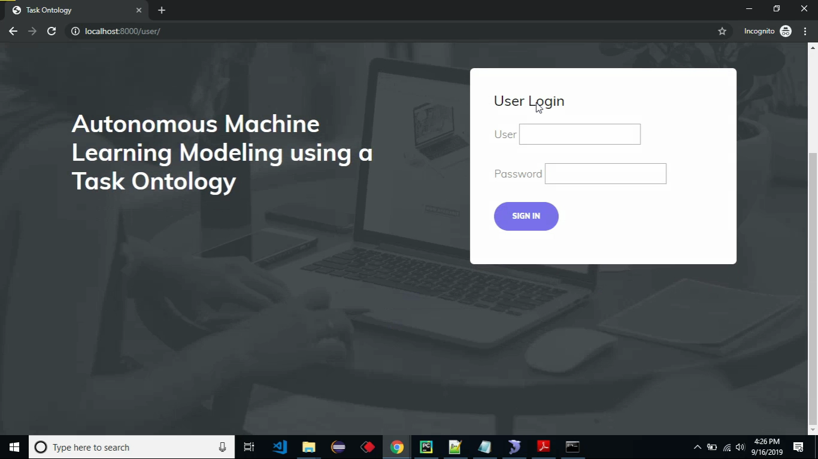
Figure.10 user login page
42
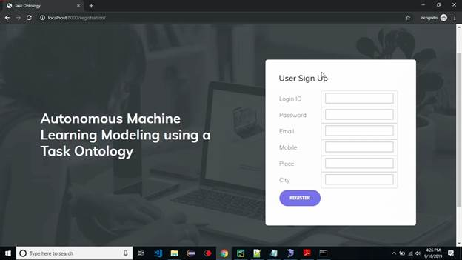
Figure.11 user sign up page

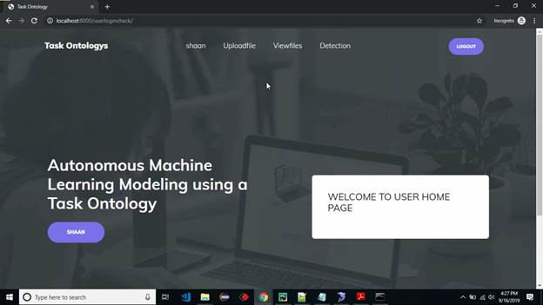
Figure.12 welcome page

43

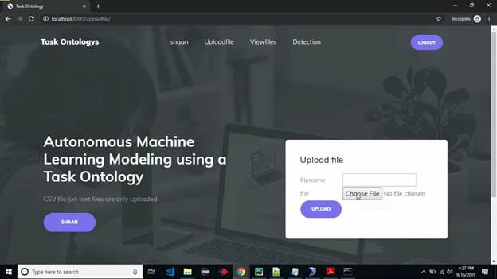
Figure.13 file upload page

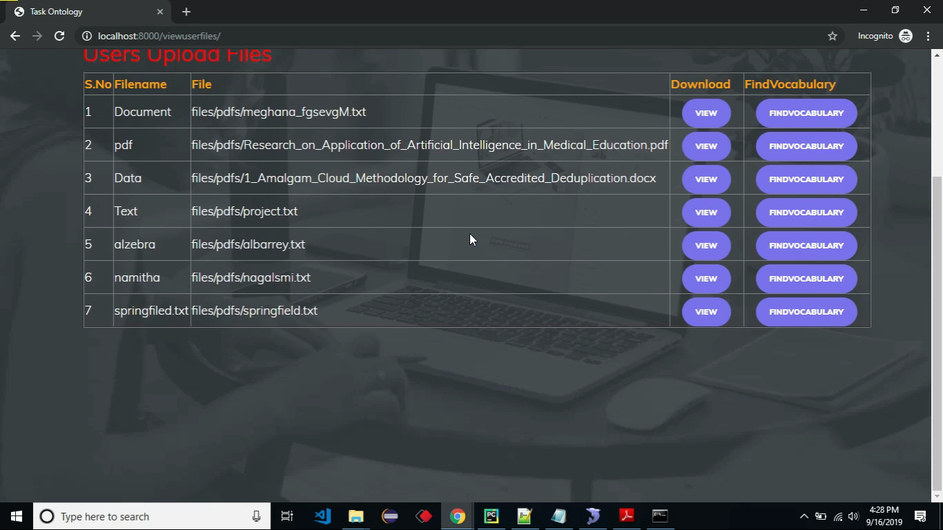

Figure.14 uploaded files page

44
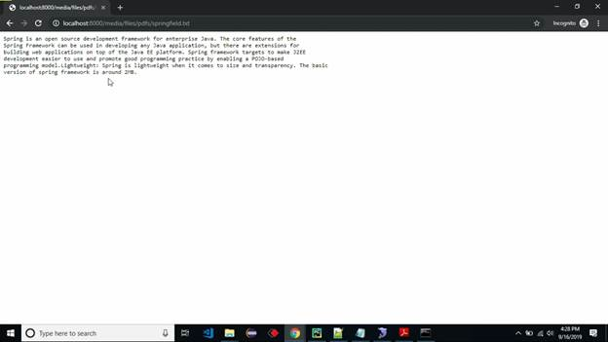

Figure.15 database entering page

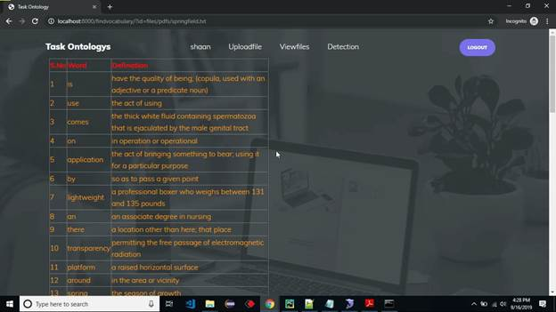

Figure.16 database page

45
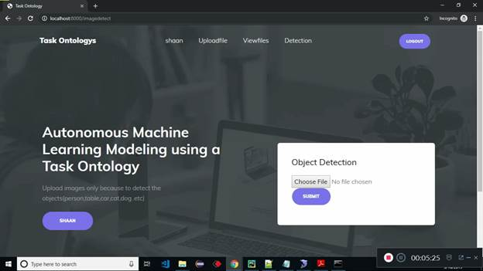

Figure.17 object identification file upload page

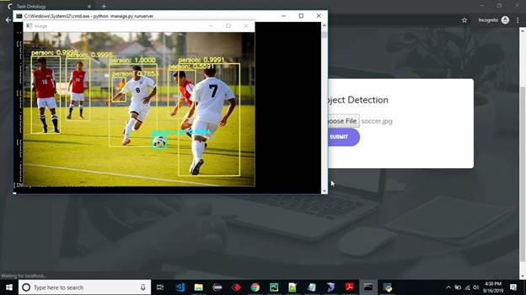
Figure.18 result page

46
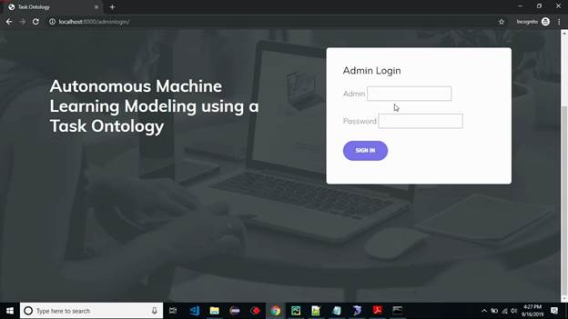

Figure.19 admin login page

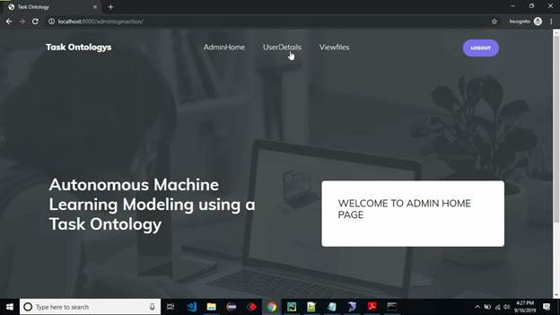

Figure.20 welcome page

47
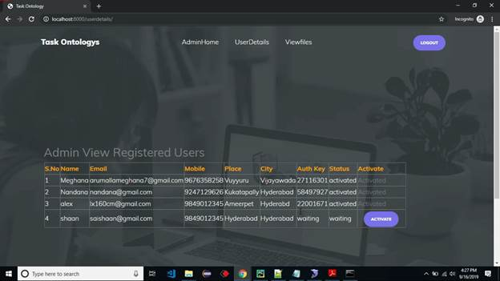

Figure.21 registered users page
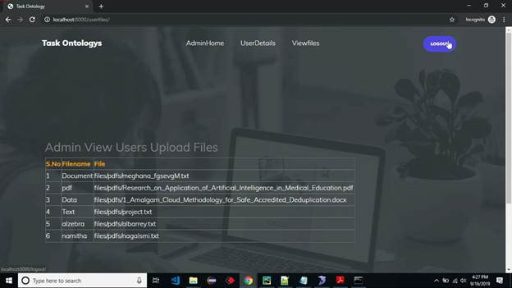

Figure.22 files uploaded page

48

CHAPTER 9: CONCLUSION

In this paper, we extracted important keywords for constructing an ontology from papers and textbooks about machine learning. Moreover we designed a task ontology based on the MEX vocabulary. We also studied workflow for the autonomous machine learning model. The proposed method is applicable for automatic workflow according to designated autonomous level. Therefore, the non-experts are capable of doing complex tasks using the proposed method and can easily implement the machine learning model in a specific application

49

CHAPTER 10: BIBLIOGRAPHY
[1] A. Martín, B. Paul Barha, C. Jianmin, C. Zhifeng, D. Andy, D. Jeffrey, et al., “TensorFlow: A System for Large-Scale Machine Learning," Operating Systems Design, and Implementation, Vol. 16, pp. 265-283, 2016.
[2] Keras, https://keras.io/accessed on April, 05, 2018.
[3] J. Yangqing, S. Evan, D. Jeff, K. Sergey, L. Jonathan, G. Ross, et al., “Caffe: Convolutional Architecture for Fast Feature Embedding,” Proceedings of the 22nd ACM International Conference on Multimedia, pp. 675-678, 2014.
[4] P. Fabian, V. Gaël, G. Alexandre, M. Vincent, T. Bertrand, G. Olivier, et al., "Scikit-learn: Machine Learning in Python," Journal of Machine Learning Research, pp. 2825-2830, 2011.
[5] Theano, http://deeplearning.net/software/theano/accessed on April, 05, 2018.
[6] K. M. Lee, K. Y. Kim, J. S. Yoo, “Autonomicity Levels and Requirements for Automated Machine Learning”. In Proceedings of the International Conference on Research in Adaptive and Convergent Systems, ACM. 2017, Sept.; 46-48.
[7] Auto-sklearn, https://automl.github.io/auto-sklearn/stable/
[8] Auto-WEKA, https://www.cs.ubc.ca/labs/beta/Projects/autoweka/
[9] H2o Driverless AI, , https://automl.github.io/ stable/
[10] Google's AutoML, https://ai.googleblog.com/2017/11/automl-forlarge-scale-image.html, 2017.
[11] C. Perez, The Deep Learning A.I. Playbook : Strategy for Disruptive Artificial Intelligence,I.M.:Intution Mach
ine, 2017
[12] V. Joaquin, S. Larisa, “Expos´e: An Ontology for Data Mining Experiments”, Third Generation Data Mining Workshop at ECML PKDD 2010.
[13] I. Mitsuru, S. Kazuhisa, K. Osamu, M. Riichiro, “Task ontology: Ontology for building conceptual problem solving models”, In proceeding of ECAI98 Workshop on Applications of Ontologies and Problem-Solving model, pp.126-133, ECA, 1998.
[14] A. F. Martins, R. A. F. De, “Models for Representing Task Ontologies”, Proceeding of the 3rd Workshops on Ontologies and their Application, 2008.
[15] S. Kanjana, S. Maleerat, “Ontology Knowledge-Based Framework for Machine Learning Concept”, iiWAS '16 Proceedings of the 18th International Conference on Information Integration and Webbased Applications and Services, pp. 50-53, 2016.
[16] P. Gustavo Correa, E. Diego, L. Agnieszka, P. Panče, S. Larisa, S. Tommaso, V. Joaquin, Z. Hamid, “ML Schema: Exposing the Semantics of Machine Learning with Schemas and Ontologies”, ICML 2018 - RML Workshop.
[17] G. Eason, B. Noble, and I. N. Sneddon, ͆MEX Interfaces: Automating Machine Learning Metadata Generation, ͇ https://www.researchgate.net/publication/305143958, 2016. [18] E.Diego,N. M. Pablo, M.Diego, C. D. Julio,Z. Amrapali,L. Jens, “MEX Vocabulary: A Lightweight Interchange Format for Machine Learning Experiments”, SEMANTiCS 2016 Proceedings of the 12th International Conference on Semantic Systems, pp. 1724, 2016

50
- W3 School – (https://www.w3schools.com/python/)
- Geek for Geeks – (https://www.geeksforgeeks.org/python-programming-language/learn-python-tutorial/)
- Python Official Documentation – (https://docs.python.org/3/tutorial/)
- Tutorials Point – (https://www.tutorialspoint.com/python/index.htm)
- Real Python – (https://realpython.com/)
- Django for Beginners – (https://djangoforbeginners.com/introduction/)
- Guru99 – (https://www.guru99.com/django-tutorial.html)

51

